How to use NESTHD1
NESTHD1 is part of the Delft3D-FLOW tools. To access NESTHD1, first set the current directory to the directory where you have stored the required input files. Then:

  - Select Tools in the Hydrodynamics selection window, see Figure F-:

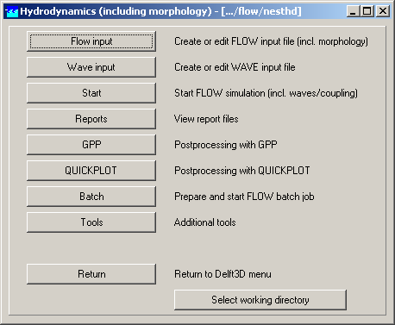
Figure F- Hydrodynamics selection window with the Tools option
Next Figure F- is displayed.

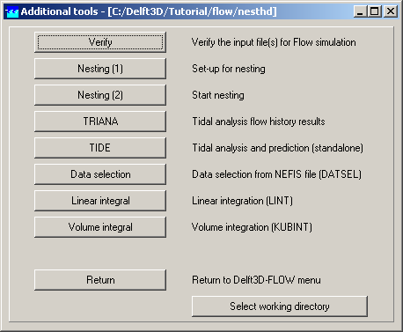
Figure F- Additional tools window with the NESTHD1 and NESTHD2 options
To start NESTHD1:

  - Select Nesting (1).

You are asked to supply the following information, see also Error: Reference source not found:

  - The filename of the grid file of the overall model.
  - The filename of the enclosure file of the overall model.
  - The filename of the grid file of the nested model.
  - The filename of the enclosure file of the nested model.
  - The filename of the boundary definition file of the nested model. This file must fulfil the conventions as specified in the Delft3D-FLOW manual.
  - The name of the file containing the nest administration. An example of this file as used for nesting of the Stonecutters Island model in the Pearl Estuary model is given in Section Error: Reference source not found.
  - The name of the file containing the position of the monitoring stations in the overall model. This file can be used directly in a Delft3D-FLOW simulation with the overall model.

